5th Grade Class Newsletter
Mrs. Aardahl and Mrs. Brinkman
For the week of 9/18/17 to 9/22/17
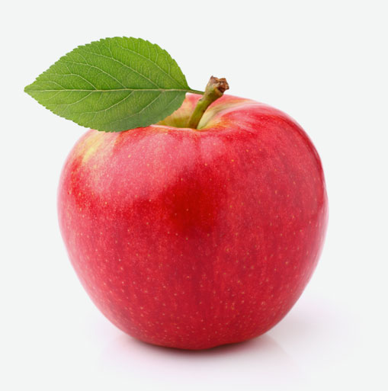

Greetings Parents!

5th grade is in full swing! We are enjoying teaching your students. Below is a glimpse of what your students are doing as well other helpful information about school:

WEEKLY SNAPSHOT:
- Math: Students completed Unit 1 (Place Value) this week, with an exam Wednesday. Students will soon learn their scores. Unit 2 (Decimals) begins on Friday. In introducing new concepts, we try to create illustrations and reference points for students from prior knowledge. On Thursday, we used actual money to help students realize that they already have some knowledge of decimals. Students will receive a packet with practice problems overviewing the entire decimal unit, which we will use in class. Parents and students may use this packet as a way to check for understanding and study for the end-of-unit exam.
- Language Arts: We began reading Hatchet this week. Students are realizing this is a “page-turner” and are asking to read more. We are combining reading skills (i.e. comprehension, anticipation) with writing skills (i.e. the elements of a summary/expository paragraph). These exercises are assembled into a portfolio or “Book Look” for Hatchet. As we discuss each chapter, students receive teaching on elements of literature. On Wednesday, students learned that stories must have conflict, and that all stories fit into one or more categories of “conflict” (i.e. character vs. nature). We played a game where students wrote “mini-stories” patterned after one of the types of conflict, with classmates guessing the type of conflict it was patterned after.
- Science: Our study of the solar system this week reinforced that subject areas are integrated in real life. We watched a brief video of the dynamic Louie Giglio. In the video, “Indescribable,” he uses scientific data, math facts, and scripture to illustrate truths about God and His creation. Students learned about guided note-taking as a way to prepare for discussion and how to distill large bodies of facts and examples into insights for discussion. Students quickly realized that using decimals to talk about large numbers is necessary in the study of the solar system – showing relevance in our next math unit.
- Social Studies: Our study of American history opened with learning about the native peoples of North America. Students are learning how to read informational texts and take notes. They will use the information they gather to compare the similarities and differences between North American tribes in order to answer the question “How does geography impact the way people live?” We will also look at the difference between generalizations and stereotypes, echoing some of the themes in one of the books we are reading, Indian In the Cupboard.
- Bible: This week, students discussed the meaning of their weekly Bible verse and made a visual study aid. Their Bible verse tests not only will assess scripture memorization, but also the meaning of the verse. Following the 5th grade curriculum sequence, we are beginning in the Old Testament and started looking at the role of covenant in God’s relationship with humankind. Students were challenged to understand the difference between a covenant and a promise.
- Integration: We listened to excerpts from Gustav Holst’s symphony “The Planets,” as well as some of NASA’s recordings of space sounds to answer the question: “What in God’s creation inspires you?”
- As always, we continue have students assess the quality of their work using the Levels of Excellence—and we are focusing on higher-level thinking skills and integrating the different subjects we are studying.

ANNOUNCEMENTS:
- Grades should be posted soon on ALMA.
- Picture day will be announced soon. 5th grade picture day will be announced as 9/27 or 9/28. Be sure to turn in your order forms soon.
- Our Specialist schedule is as follows:
Monday | Tuesday | Wednesday | Thursday | Friday
Music (9:35-10:15) | PE (8:50-9:30) | Chapel (8:55-9:30) | Band (10:20-11:00) | PE (8:50-9:30)
Spanish (1:00-1:30) | Band (10:20-11:00) | Technology (9:35-10:15) | Music (11:05-11:45) | Orchestra (10:20-11:00)
 |  | Orchestra (10:20-11:00) | Enrichment (all day) | Reading Buddies (TBA)

REMINDERS:
- Students are expected to write assignments and due dates in their planner. While the class often does this together, it is your student’s job to fill it and to keep it up to date. They should bring home their assignment folder each night with their planner to help them keep track of their work.
- Please remind your student that homework must be turned in at the start of class on the day that it is due in order to be on-time.

Enjoy your weekend!

Sincerely,
Mrs. Aardahl and Mrs. Brinkman

Moira Aardahl: aardahl.m@ecsolympia.com (360) 357-5590 ext. 105
Megan Brinkman: brinkman.m@ecsolympia.com (360) 357-5590 ext. 104

